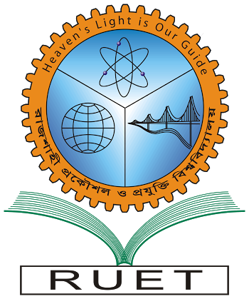“Heaven’s light is our guide”

**Rajshahi University of Engineering & Technology**

**Department of Computer Science & Engineering**

**Course No: CSE 2202**

**Course Title: Computer Algorithms Sessional**

Experiment No: 05

Experiment Name:Solvea **Tree Vertex Splitting Problem (TVSP)**.

|  |  |
| --- | --- |
| Submitted By:  ***Saifur Rahman***  *Roll No:* ***1703018***  *Section: ’17-A*  *Class: 2nd year (Even Semester)* | Submitted To:  ***Dr. MD. Ali Hossain***  *Associate Professor,*  *Dept. of CSE,*  *RUET.* |

***Date of Experiment: 7th March, 2020***

***Date of Submission: 14th March, 2020***